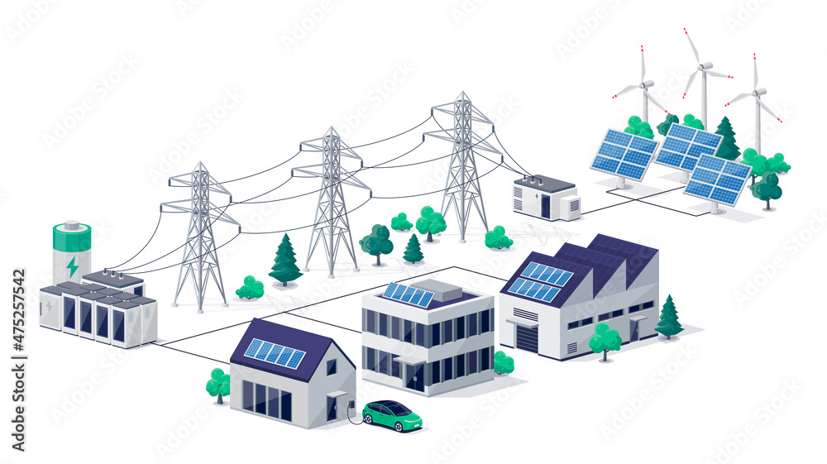Exploring the Role of Energy Storage Transformers
As the global energy landscape rapidly shifts towards renewable sources, the importance of efficient energy storage systems has never been greater. At the heart of these systems are energy storage transformers (ESTs), which play a crucial role in managing and optimizing the flow of electricity between the grid and storage systems. This article delves into the key aspects of energy storage transformers, their functions, and the benefits they bring to the energy sector.

What is an Energy Storage Transformer?
An energy storage transformer is a specialized type of transformer designed to handle the unique demands of energy storage systems. These transformers are integral in the connection between the energy storage unit—such as batteries or flywheels—and the electrical grid. Their primary function is to step up or step down the voltage to appropriate levels, ensuring seamless integration and efficient energy transfer.

Key Functions and Features
-Bidirectional Power Flow: Unlike conventional transformers, energy storage transformers must handle bidirectional power flow. This means they can manage the transfer of electricity both to and from the storage system, allowing for efficient charging and discharging operations.
-Voltage Regulation: Energy storage systems require precise voltage control to maintain stability and efficiency. ESTs are equipped with advanced voltage regulation capabilities to ensure that the energy flow remains consistent, even during fluctuations in demand or supply.
-Efficiency and Reliability: Given the critical nature of energy storage, these transformers are designed for high efficiency and reliability. They often incorporate advanced cooling systems and materials to withstand the stresses of constant operation and fluctuating loads.

Applications in the Energy Sector
Energy storage transformers are pivotal in several key applications within the energy sector:
-Renewable Energy Integration: ESTs facilitate the smooth integration of renewable energy sources, such as solar and wind, into the grid. By storing excess energy during periods of low demand and releasing it during peak times, they help balance supply and demand, ensuring a stable energy supply.
-Grid Stability and Peak Shaving: By enabling energy storage systems to operate efficiently, ESTs contribute to grid stability. They allow for peak shaving—reducing the load on the grid during high-demand periods—thereby minimizing the need for additional power plants and reducing overall energy costs.
-Microgrids and Off-Grid Systems: In remote or off-grid areas, energy storage transformers are essential for maintaining a reliable power supply. They enable microgrids to function independently, storing energy during periods of excess production and providing power when needed.

The Future of Energy Storage Transformers
As the energy sector continues to evolve, the demand for advanced energy storage solutions will only grow. Energy storage transformers will play an increasingly important role in ensuring the efficiency, reliability, and stability of the global energy grid. With ongoing advancements in materials, design, and technology, these transformers are set to become even more integral to the future of energy.
In conclusion, energy storage transformers are a critical component of modern energy systems. Their ability to manage bidirectional power flow, regulate voltage, and ensure efficient energy transfer makes them indispensable in the transition to a more sustainable and resilient energy infrastructure. As we move towards a greener future, the role of these transformers will only become more significant, shaping the way we store and utilize energy for generations to come.
探索储能变压器的作用
随着全球能源格局迅速向可再生能源转型，高效储能系统的重要性变得愈发突出。储能变压器（Energy Storage Transformers, ESTs）作为这些系统的核心，在电网与储能系统之间的电力管理和优化中发挥着关键作用。本文深入探讨储能变压器的关键特性、功能及其为能源行业带来的益处。
什么是储能变压器？
储能变压器是一种专门设计用于满足储能系统独特需求的变压器。它们在储能单元（如电池或飞轮）与电网之间的连接中起着不可或缺的作用。其主要功能是将电压升高或降低至适当水平，确保无缝集成和高效的能量传输。
关键功能与特性
双向电力流动：与传统变压器不同，储能变压器必须能够处理双向电力流动。这意味着它们可以管理电力从储能系统流入和流出的过程，从而实现高效的充电和放电操作。

电压调节：储能系统需要精确的电压控制以保持稳定性和效率。储能变压器配备了先进的电压调节功能，确保即使在需求或供应波动时，能量流动也能保持一致。

效率与可靠性：鉴于储能的关键性，这些变压器被设计为高效且可靠。它们通常采用先进的冷却系统和材料，以承受持续运行和负载波动的压力。
在能源领域的应用
储能变压器在能源领域的多个关键应用中发挥着重要作用：
可再生能源整合：储能变压器促进了太阳能和风能等可再生能源的平稳并网。通过在低需求期间存储多余能量并在高峰时段释放，它们帮助平衡供需，确保稳定的能源供应。

电网稳定性与削峰填谷：通过使储能系统高效运行，储能变压器有助于电网稳定。它们支持削峰填谷——在高需求期间减少电网负荷，从而减少对额外发电厂的需求并降低整体能源成本。

微电网与离网系统：在偏远或离网地区，储能变压器对于维持可靠的电力供应至关重要。它们使微电网能够独立运行，在能源生产过剩时存储能量，并在需要时提供电力。
储能变压器的未来
随着能源行业的不断发展，对先进储能解决方案的需求将只增不减。储能变压器将在确保全球电网的效率、可靠性和稳定性方面发挥越来越重要的作用。随着材料、设计和技术的不断进步，这些变压器将在未来的能源格局中变得更加不可或缺。
结论
储能变压器是现代能源系统的关键组成部分。它们能够管理双向电力流动、调节电压并确保高效能量传输，使其在向更可持续和更具弹性的能源基础设施过渡中不可或缺。随着我们迈向更绿色的未来，这些变压器的作用将变得更加重要，塑造我们存储和利用能源的方式，造福子孙后代。

